SimplyFly

Problem statement:
The Simply Fly is an online air ticket booking web-based application that allows users to search for
air routes, view schedules, book tickets, and make payments online. It connects passengers with Flight owners, simplifying the process of reserving Flight seats, planning journeys, and managing bookings.

Scope
- User Registration and Authentication: Provide user registration and secure login for passengers.
- Air Route Search: Enable users to search for flight routes based on origin, destination, and date.
- Route Details and Booking: Display detailed route information, seat availability, and ticket prices. Allow users to select seats, make reservations.
- Ticket Confirmation: Send booking confirmations with e-tickets to users.
- User Profiles: Enable users to manage their profiles, view booking history, and cancel bookings.
- Admin Dashboard: Offer flight owner/admins a dashboard to manage schedules, flight availability, and bookings.

  - Frontend: HTML,CSS, Bootstrap,JS,ECMA Script,JSP, ,Spring Thymeleaf.
  - Backend: Java, Spring Boot with Hibernate / Data JPA for API development.
  - Database: MySql
  - Authentication: JSON Web Tokens (JWT) for secure user authentication.
Reference Link: https://www.cleartrip.com/

Use case Diagram:
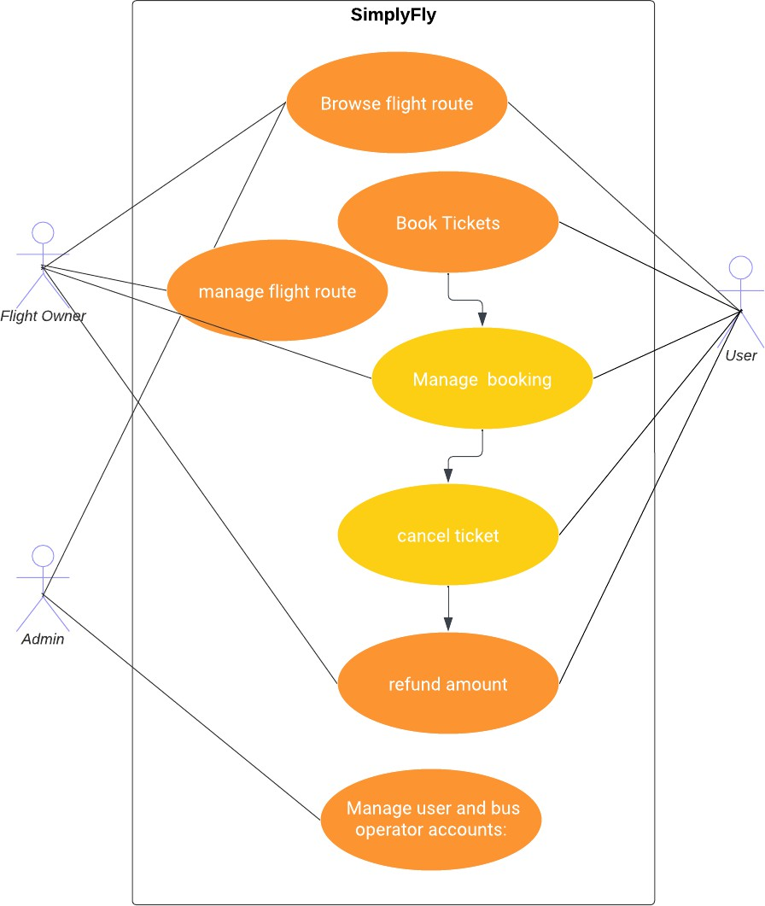

Use Cases:
Actor: User
    - Use Case: User Registration and login.
    - Use Case: Search flights.
    - Use Case: Select Seats and Make Reservation.
    - Use Case: Payment Processing.
    - Use Case: Cancel Tickets.
    - Use Case: View booking history.

Actor: Flight Owner
    - Use Case: Log In as flight owner.
    - Use Case: Manage the flight.
    - Use Case: Manage Bookings.
    - Use Case: Logout.

Actor: Administrator
    - Use Case: Log In.
    - Use Case: User Management.
    - Use Case: Manage flight Owner.
    - Use Case: Manage Bookings.
    - Use Case: Manage Routes.
    - Use Case: Logout.

System: Security and Authentication
    - Use Case: Authenticate User.

System: Database Management
    - Use Case: Store Flight routes and schedule Information.
    - Use Case: Store Booking Information.
    - Use Case: Store User and Flight Operator Information.

Development Process:
- User and Flight Owner Registration:
  - User and Flight Owner can create accounts, providing personal details (name, gender, contact number, address, etc.)
  - The system validates the information and creates user profiles.
  - Users and Flight Owner log in using their credentials (username/email and password).

User's Dashboard:
  - Passengers can search for Flight routes by specifying the date of journey, origin, and destination.
    - To fill origin and destination location name should be typed and filled with auto suggestions.
    - To fill date of journey date should be selected from calendar. Date must be selected from today and it should be validated.
  - The system displays routes, schedules, and fares, Baggage Information(Check-in: weight in kg/ Adult, Cabin: weight in kg/ Adult) for the user search.

  - Users have the option to select their preferred seats. available seats are allowed to select and booked seats are not available for booking.
  - Users have the option to select more than one seat and price should be calculated as per number of seat selection.
  - Users can book the tickets as they selected and can be viewed in manage booking.
  - Passengers can view the history of booking and manage their booking history.
  - They can cancel bookings and request refunds as needed.

Flight owner Dashboard:
  - Flight owners can add, edit, or remove Flight routes and schedules. Flight route and schedules should have following details
    - Flight name, number, Flight Baggage Information, number of seat, origin, destination, timings, fare.
  - They can set fares and manage seat availability.
  - Flight owners can view the tickets booked by the user.
  - Flight owners can refund the amount of booked tickets which are cancelled by the user.

Administrators Dashboard
  - Administrators can manage(delete) user accounts and Flight owner accounts.
  - Admins can manage the booked tickets by the user.
  - Administrators can access a dashboard to manage Flight routes.

Security and Compliance:
  - User authentication and authorization are enforced to ensure data privacy.

JWT Authentication:
JWT authentication involves generating a token upon successful user login and sending it to the client. The client includes this token in subsequent requests to authenticate the user.
  - User Login: Upon successful login (using valid credentials), generate a JWT token on the server.
  - Token Payload: The token typically contains user-related information (e.g., user ID, roles, expiration time).
  - Token Signing: Sign the token using a secret key known only to the server. This ensures that the token hasn't been tampered with.
  - Token Transmission: Send the signed token back to the client as a response to the login request.

  - Client Storage: Store the token securely on the client side (e.g., in browser storage or cookies).

JWT Authorization:
JWT authorization involves checking the token on protected routes to ensure that the user has the required permissions.
  - Protected Routes: Define routes that require authentication and authorization.
  - Token Verification:
    - Extract the token from the request header.
    - Verify the token's signature using the server's secret key.
  - Payload Verification:
    - Decode the token and extract user information.
    - Check user roles or permissions to determine access rights.
  - Access Control: Grant or deny access based on the user's roles and permissions.

Logout:
  - Logging out involves invalidating the JWT token on both the client and the server to prevent further unauthorized requests.

Project Development Guidelines
The project to be developed based on the below design considerations.

1 | Backend Development | - Use Rest APIs (Springboot/ASP.Net Core WebAPI to develop the services  - Use Java/C# latest features  - Use ORM with database  - perform backend data validation  - Use Swagger to invoke APIs  - Implement API Versioning  - Implement security to allow/disallow CRUD operations  - Message input/output format should be in JSON (Read the values from the property/input files, wherever applicable). Input/output format can be designed as per the discretion of the participant.  - Any error message or exception should be logged and should be user-readable (not technical)  - Database connections and web service URLs should be configurable  - Implement Unit Test Project for testing the API  - Implement JWT for Security  - Implement Logging

- Follow Coding Standards with proper project structure.

Frontend Constraints

1. | Layout and Structure | Create a clean and organized layout for your registration and login pages. You can use a responsive grid system (e.g., Bootstrap or  Flexbox) to ensure your design looks good on various screen sizes.
2 | Visual Elements | Logo: Place your application's logo at the top of the page to establish  brand identity.
Form Fields: Include input fields for email/username and password for both registration and login. For registration, include additional
fields like name and possibly a password confirmation field.
Buttons: Design attractive and easily distinguishable buttons for
"Register," "Login," and "Forgot Password" (if applicable).
Error Messages: Provide clear error messages for incorrect login
attempts or registration errors.
Background Image: Consider using a relevant background image to
add visual appeal.
Hover Effects: Change the appearance of buttons and links when
users hover over them.
 |  | Focus Styles: Apply focus styles to form fields when they are selected
3. | Color Scheme and Typography | Choose a color scheme that reflects your brand and creates a visually pleasing experience. Ensure good contrast between text and  background colors for readability. Select a legible and consistent typography for headings and body text.
4. | Registration Page, add Flight route, booking tickets by user | Form Fields: Include fields for users to enter their name, email,  password, and any other relevant information. Use placeholders and labels to guide users.
Validation: Implement real-time validation for fields (e.g., check email format) and provide immediate feedback for any errors.
Form Validation: Implement client-side form validation to ensure required fields are filled out correctly before submission.
 | Registration Page | Password Strength: Provide real-time feedback on password strength using indicators or text.  Password Requirements: Clearly indicate password requirements  (e.g., minimum length, special characters) to help users create strong passwords.
Registration Success: Upon successful registration, redirect users to
the login page.
5. | Login Page | Form Fields: Provide fields for users to enter their email and  password.
Password Recovery: Include a "Forgot Password?" link that allows
users to reset their password.
6. | Common to UI Development | - Use JSP/Spring Thymeleaf for the UI.  - Implement Forms, databinding, validations, error message in required pages.  - Implement Routing and navigations.

- Use JavaScript to enhance functionalities.
- Implement External and Custom JavaScript files.
- Implement Typescript for Functions Operators.
- Any error message or exception should be logged and should be user-readable (and not technical).
- Follow coding standards.
- Follow Standard project structure.
- Design your pages to be responsive so they adapt well to different screen sizes, including mobile devices and tablets.

